1093045033 統計四 顧以恩

picture 1 destroyed city in 2200AD

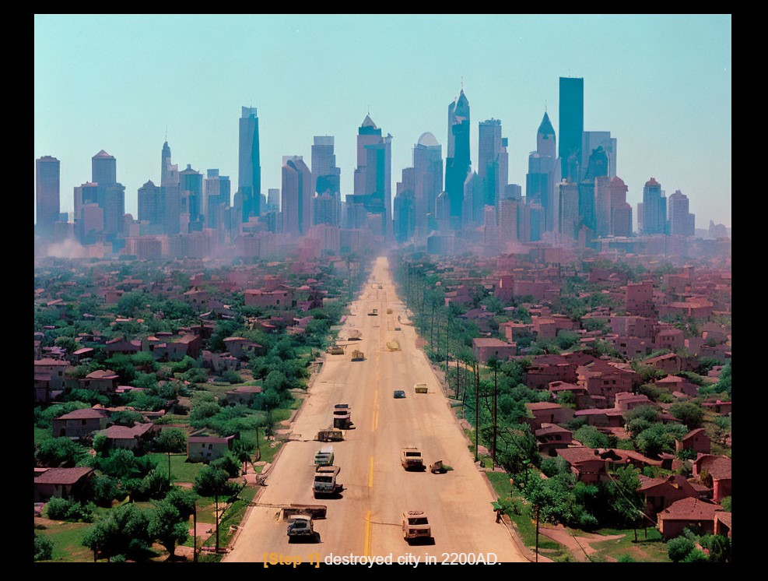

picture 2 add some helicopter in the sky

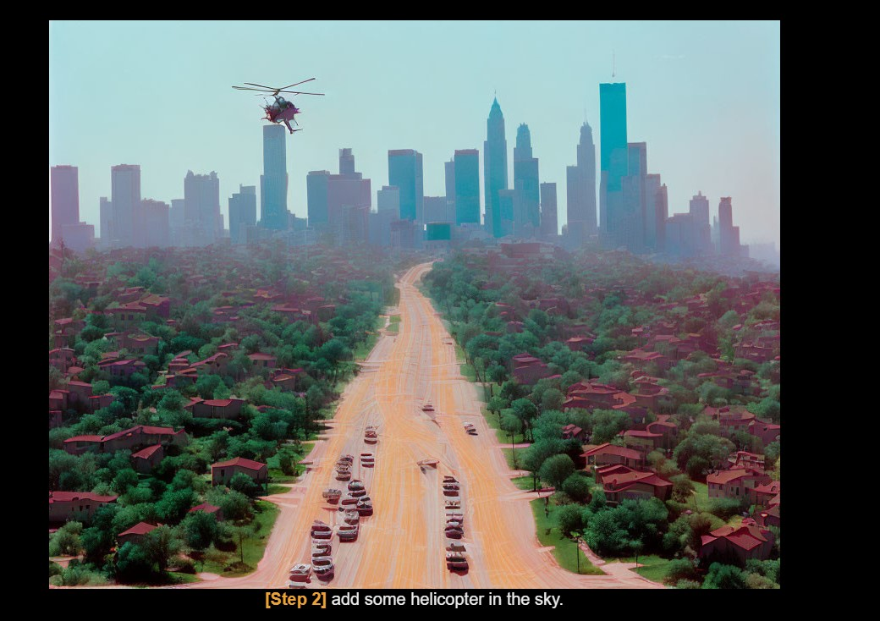

picture 3 the village and the city are in a war people and cars are lining up to escape

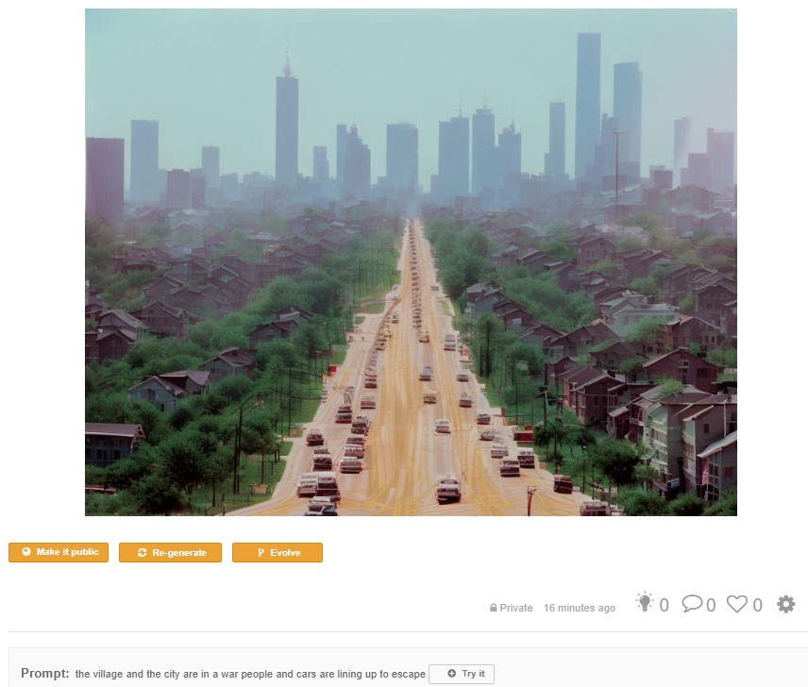

picture 4 destroyed city in 2200AD

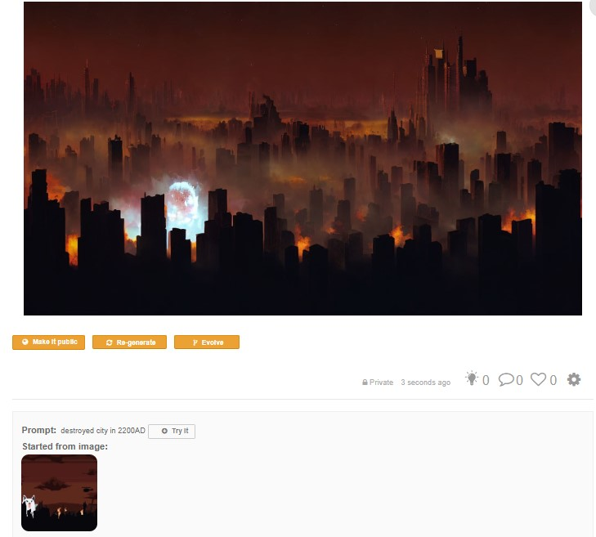

start from:

